Computing Assignment 7

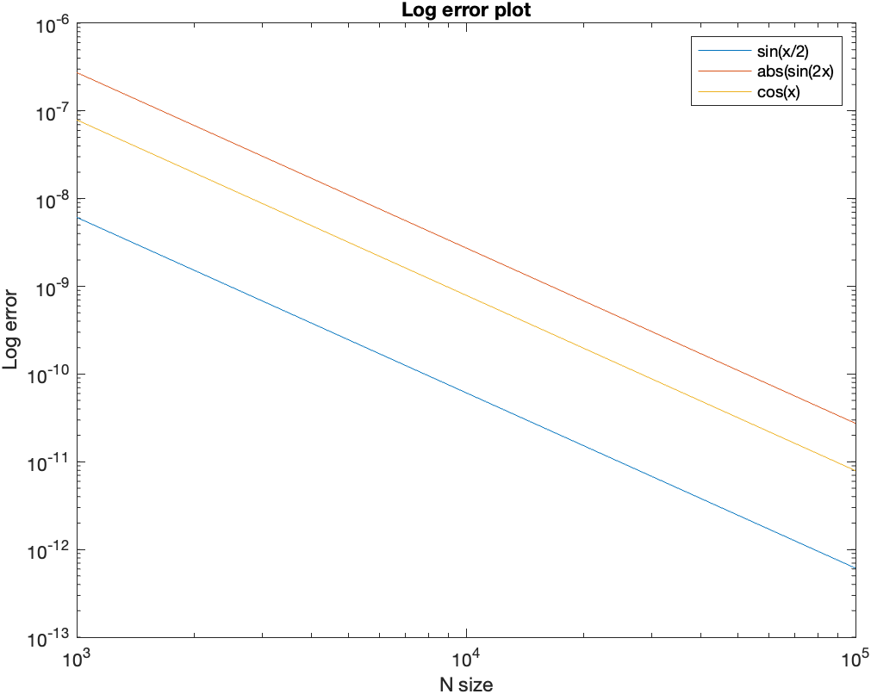The integral of $f(x)$ = $x^{3}$ over [0,1] with 100 end-points converges to 0.25002500000000.

The log error plot with respect to the interval [0, $π$/3] is shown above. When passing the error points to the polyfit function with a degree of 1 we find the following slope values:

|  |  |  |
| --- | --- | --- |
|  |  |  |
| -1.99994394 | 1.999998043404123 | -1.999997760465159 |

This gives the rate of convergence of O(n^2), for $Sin(x/2)$, $|sin\left(2x\right)|$ and $cos⁡(x)$.

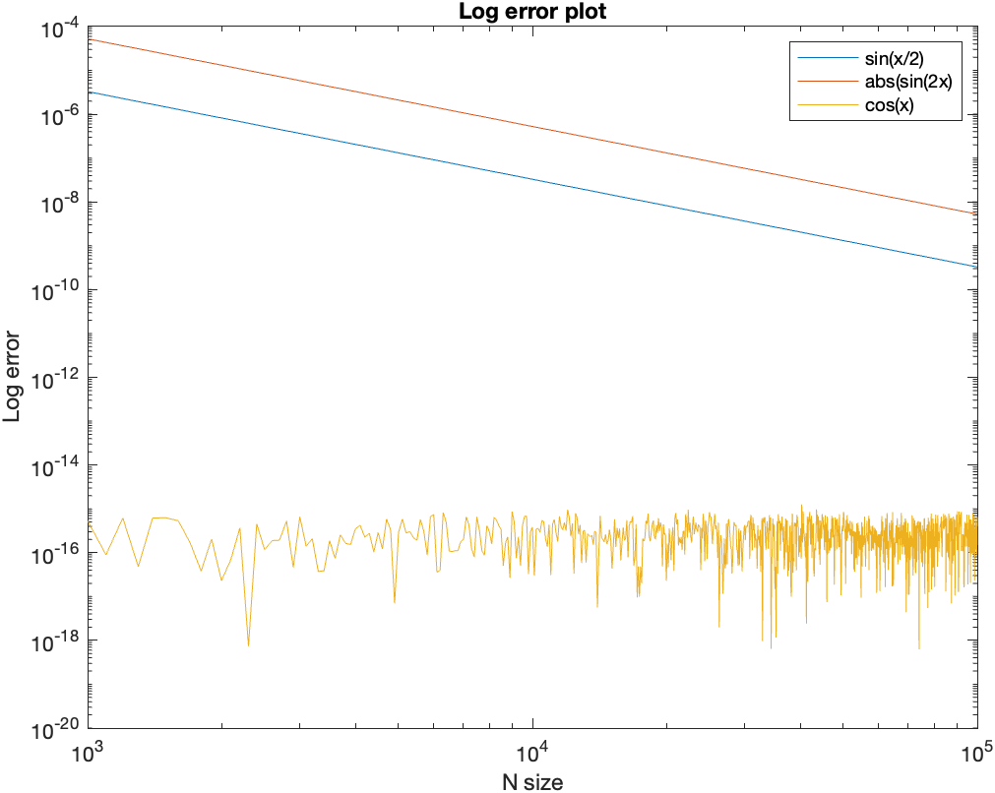When computing the absolute error on the interval [0,2 $π$] gives the following plot:

The slope of the lines turn out to be:

|  |  |  |
| --- | --- | --- |
|  |  |  |
| -1.99999950 | -2.000000062906693 | NaN |

This gives the rate of convergence of O(n^2) $Sin(x/2)$ and $|sin\left(2x\right)|$ for all the functions. Since the estimate for $cos⁡(x)$ is very close to machine epsilon it cant further converge which causes the slope of the line to be NaN.

$|sin\left(2x\right)|$ converges the fastest.

Cos(x) is always close to machine epsilon in the interval [0,2pi] because it is smooth and periodic in the integration interval. It is not the case in the other functions which causes the error of the rule to the O(N^-2) bound. Moreover, the function is symmetrical about its midpoint. So the shortfall from the true curve on the left side is exactly matched by the excess above the true curve on the right.